Edit ORCID in Pure
Should you discover an error in connection with your ORCID registration in Pure, it is possible to edit your profile. Please follow the instructions below for editing ORCID in Pure.
In order to edit your ORCID in Pure, you must log on to Pure and click on Edit profile: 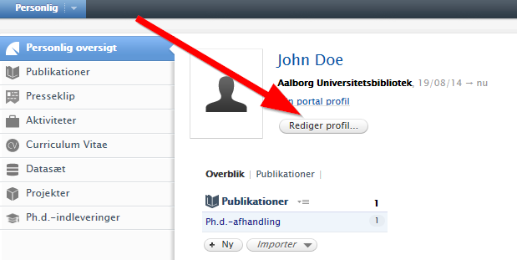

- Click on Edit in the new window: 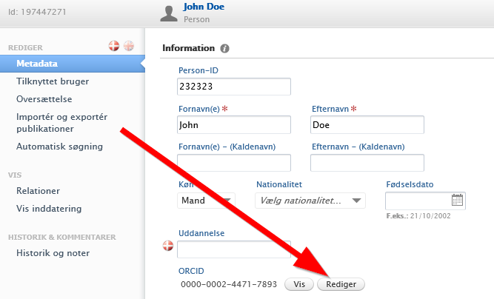
- In the following window, you enter the correct ORCID and click on the Add button: 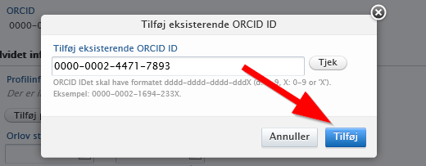

- Your ORCID is now corrected – please click on Save to save the changes in Pure: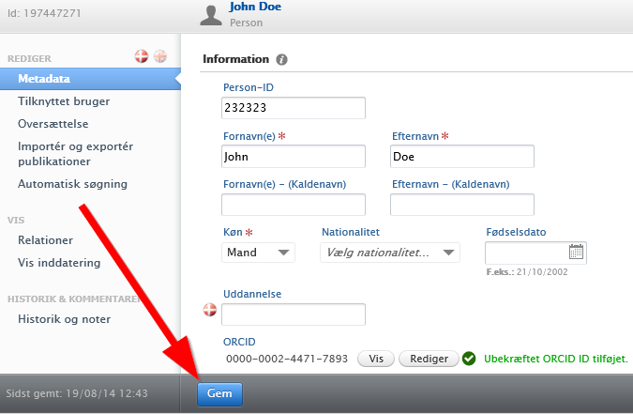

- When you return to the start page in Pure, your ORCID has been changed: 