Konfiguration af Pure til brug for
ORCID-implementering
For organisationerne i det danske ORCID-konsortium er det muligt at indhente et ORCID ID og en såkaldt hemmelig ORCID-nøgle fra ORCID – se beskrivelsen her. Når disse er indtastet i Pure opnås mulighed for at oprette ORCIDs gennem Pure og tilknytte ORCIDs til Pure-profilerne. Det er muligt at tilknytte eksisterende ORCIDs uden denne konfiguration.
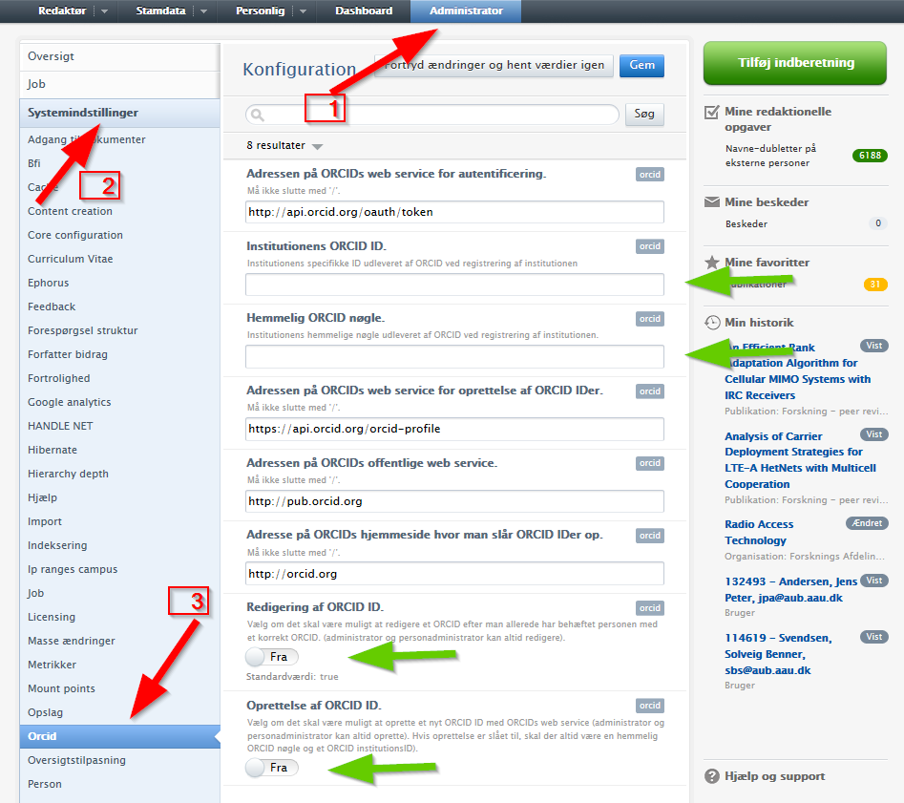

Når en forsker har fået oprettet et ORCID modtager personen en e-mail, hvor personen bliver bedt om at gøre det nye ORCID aktivt. Sker dette ikke inden 10 dage bliver det nye ORCID automatisk aktivt.
E-mailen ser sådan ud:

Dear John doe,
Aalborg University created an ORCID Account for you. This account provides you with a unique research identifier (an ORCID iD) that you can use in your publications and grants, and a place (an ORCID Record) to list information about your professional research activities.
WHAT DO YOU NEED TO DO?
Within the next 10 days, please review the information that Aalborg University entered as a courtesy on your behalf. Once you have logged in the first time, your account will become active, and you will have complete control over the privacy of your record and the information it contains. To review your record, set a password and make changes, click your unique link below, or copy and paste it into your browser:
https://orcid.org/claim/VnhURFpBdVBFOXI3Nnll9
WHAT HAPPENS IF YOU DO NOTHING?
If you take no action, your ORCID Record will become active after the 10-day period. When your Record becomes active, any information Aalborg University may have marked as "viewable by everyone" (public) will be viewable in the ORCID Registry and freely available to the public.
WHAT IS ORCID?
Launched in October 2012, the ORCID Registry contains unique identifiers (ORCID iDs) for researchers and scholars. In addition, the Registry enables you to designate "Trusted Organizations" with which you can exchange information. Many publishers and granting agencies have started to ask for ORCID iDs with submissions to better link researchers with their research activities. ORCID iD holders control what is in their Records and who can see this information. Learn more about ORCID at https://orcid.org/.
Read ORCID's Privacy Policy at https://orcid.org/privacy-policy/. If you have any questions or need help, please contact the ORCID support team at support@orcid.org or visit http://support.orcid.org.

Kind Regards,
The ORCID Team
support@orcid.org
https://orcid.org/

You have received this email as a service announcement related to your ORCID Account.
email preferences | privacy policy | ORCID, Inc. | 10411 Motor City Drive, Suite 750, Bethesda, MD 20817, USA | ORCID.org

